**Q1) Shell script which accepts input as a file or directory and displays message whether it’s a file or directory.**

**echo "Qarq90 - 210451 "**

**echo -n "Enter name of File or Directory:"**

**read file**

**if [ -f $file ]; then**

**echo "It is a File";**

**elif [ -d $file ]; then**

**echo "It is a Directory";**

**else**

**echo "It's neither a File nor a Directory";**

**fi**

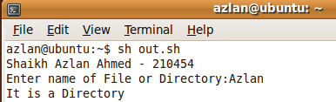

**Q2) Shell script to copy source file into the destination file.**

**echo "Qarq90 - 210451 "**

**echo -n "Enter source File:"**

**read src**

**echo -n "Enter destination File:"**

**read dest**

**if [ -f $src ]; then**

**echo "Checking Source.....";**

**else**

**echo "File doesn't exists!";**

**exit 1;**

**fi**

**if [ -f $dest ]; then**

**echo "File already exists,cannot override";**

**exit 2;**

**else**

**echo "Checking destination...";**

**fi**

**cp $src $dest**

**echo "File copied successfully"**

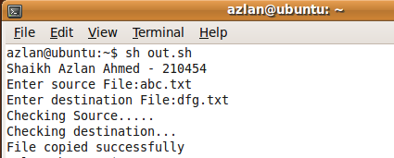

**Q3) Shell script to display list of all directories in your home directory:**

**echo "Qarq90 - 210451 "**

**echo "All directories are:"**

**for file in \***

**do**

**if [ -d $file ];then**

**echo "$file";**

**fi**

**done**

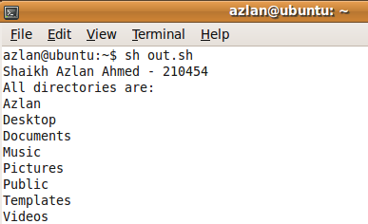

**Q4) Shell script to display list of all files in your home directory:**

**echo "Qarq90 - 210451 "**

**echo "All directories are:"**

**for file in \***

**do**

**if [ -f $file ];then**

**echo "$file";**

**fi**

**done**

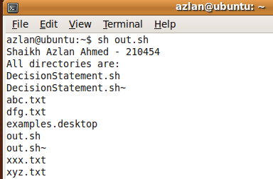

**Q5) Write a file handling program. First check whether it is file or directory, then if it is a file then program shall ask user for choices of copying, removing and renaming files. Use Case Statement.**

**echo "Enter the file name"**

**read file1**

**if [ -f $file1 ]; then**

**echo "It is a file"**

**else**

**echo "It is a directory"**

**exit 1**

**fi**

**echo -e "1) Copy"**

**echo -e "2) Remove"**

**echo -e "3) Rename"**

**read ch**

**case $ch in**

**1)**

**echo -n "Enter target file name : "**

**read targ**

**if [ -f $targ ]**

**then**

**echo "File $targ exist, cannot overwrite"**

**exit 2**

**fi**

**cp $file1 $targ**

**status=$?**

**if [ $status -eq 0 ]**

**then**

**echo 'File copied successfully'**

**else**

**echo 'Problem copuing file'**

**fi;;**

**2)**

**rm -i $file1;;**

**3)**

**echo -n "Enter new file Name"**

**read file2**

**mv $file1 $file2**

**echo -n "File has been Renamed Successfully";;**

**esac**

